How to localize Key Map of Soft Keyboard

In order to change text or layout of key map, App developer should change the key declaration in “softkey data list”.

App developer need not define Column and Row directly. KeyMap generator algorithm will split the grid by searching the whole “SoftKey data list” and figuring out the number of column and row.

First, open file \Keyboard\Themes\Generic.xaml and find the style “SoftKey data list”.

- To remove a key in key map, directly remove the declaration of that key.

- To change/add a key in key map,
  - If it is a normal key, set its location and Key of NameKeyPairs property as follows.

<l:SoftKeyData Column="6" Row="1">
<l:SoftKeyData.NameKeyPairs>
<l:NameKeyPair Key="g" />
<l:NameKeyPair Key="G" />
</l:SoftKeyData.NameKeyPairs>
</l:SoftKeyData>

  - If it is a control key, set its location and DisplayName of NameKeyPairs property.
ControlKey property can also be set. However, if its ControlKey is not in the set {Back, Space, Close, Shift, Caps, Normal}, App developer should handle this key by himself.

<l:SoftKeyData ControlKey="Close" Column="5" ColumnSpan="2">
<l:SoftKeyData.NameKeyPairs>
<l:NameKeyPair DisplayName="Close" />
</l:SoftKeyData.NameKeyPairs>
</l:SoftKeyData>

Note: NameKeyPair indicates key’s content in two key maps. User can provide one or two l:NameKeyPair. If only one is provided, this key has the same content in two key maps.
1st Sample: Chinese Soft Keyboard

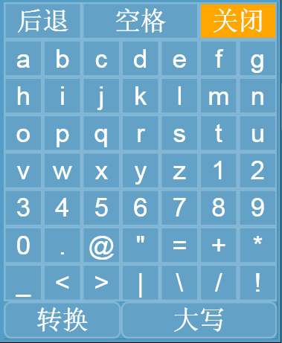

<c:ArrayList x:Key="{ComponentResourceKey TypeInTargetAssembly={x:Type l:SoftKeyboard},ResourceId=SoftKeyDataList}">
<l:SoftKeyData ControlKey="Back" ColumnSpan="2">
<l:SoftKeyData.NameKeyPairs>
<l:NameKeyPair DisplayName="后退" />
</l:SoftKeyData.NameKeyPairs>
</l:SoftKeyData>
<l:SoftKeyData ControlKey="Space" Column="2" ColumnSpan="3">
<l:SoftKeyData.NameKeyPairs>
<l:NameKeyPair DisplayName="空格" Key=" " />
</l:SoftKeyData.NameKeyPairs>
</l:SoftKeyData>
<l:SoftKeyData ControlKey="Close" Column="5" ColumnSpan="2">
<l:SoftKeyData.NameKeyPairs>
<l:NameKeyPair DisplayName="关闭" />
</l:SoftKeyData.NameKeyPairs>
</l:SoftKeyData>

……
<!--====================================================
This part is just the same as the default one.
========================================================-->
……

<l:SoftKeyData ControlKey="Shift" Row="8" ColumnSpan="3">
<l:SoftKeyData.NameKeyPairs>
<l:NameKeyPair DisplayName="转换" />
</l:SoftKeyData.NameKeyPairs>
</l:SoftKeyData>
<l:SoftKeyData ControlKey="Caps" Column="3" Row="8" ColumnSpan="4">
<l:SoftKeyData.NameKeyPairs>
<l:NameKeyPair DisplayName="大写" />
<l:NameKeyPair DisplayName="小写" />
</l:SoftKeyData.NameKeyPairs>
</l:SoftKeyData>
</c:ArrayList>
2nd Sample: Numeric Soft Keyboard

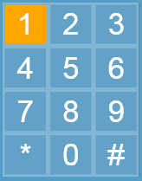

<c:ArrayList x:Key="{ComponentResourceKey TypeInTargetAssembly={x:Type l:SoftKeyboard},ResourceId=SoftKeyDataList}">

<l:SoftKeyData Row="0" Column="0">
<l:SoftKeyData.NameKeyPairs>
<l:NameKeyPair Key="1" />
</l:SoftKeyData.NameKeyPairs>
</l:SoftKeyData>
<l:SoftKeyData Row="0" Column="1">
<l:SoftKeyData.NameKeyPairs>
<l:NameKeyPair Key="2" />
</l:SoftKeyData.NameKeyPairs>
</l:SoftKeyData>
<l:SoftKeyData Row="0" Column="2">
<l:SoftKeyData.NameKeyPairs>
<l:NameKeyPair Key="3" />
</l:SoftKeyData.NameKeyPairs>
</l:SoftKeyData>
<l:SoftKeyData Row="1" Column="0">
<l:SoftKeyData.NameKeyPairs>
<l:NameKeyPair Key="4" />
</l:SoftKeyData.NameKeyPairs>
</l:SoftKeyData>
<l:SoftKeyData Row="1" Column="1">
<l:SoftKeyData.NameKeyPairs>
<l:NameKeyPair Key="5" />
</l:SoftKeyData.NameKeyPairs>
</l:SoftKeyData>
<l:SoftKeyData Row="1" Column="2">
<l:SoftKeyData.NameKeyPairs>
<l:NameKeyPair Key="6" />
</l:SoftKeyData.NameKeyPairs>
</l:SoftKeyData>
<l:SoftKeyData Row="2" Column="0">
<l:SoftKeyData.NameKeyPairs>
<l:NameKeyPair Key="7" />
</l:SoftKeyData.NameKeyPairs>
</l:SoftKeyData>
<l:SoftKeyData Row="2" Column="1">
<l:SoftKeyData.NameKeyPairs>
<l:NameKeyPair Key="8" />
</l:SoftKeyData.NameKeyPairs>
</l:SoftKeyData>
<l:SoftKeyData Row="2" Column="2">
<l:SoftKeyData.NameKeyPairs>
<l:NameKeyPair Key="9" />
</l:SoftKeyData.NameKeyPairs>
</l:SoftKeyData>
<l:SoftKeyData Row="3" Column="0">
<l:SoftKeyData.NameKeyPairs>
<l:NameKeyPair Key="*" />
</l:SoftKeyData.NameKeyPairs>
</l:SoftKeyData>
<l:SoftKeyData Row="3" Column="1">
<l:SoftKeyData.NameKeyPairs>
<l:NameKeyPair Key="0" />
</l:SoftKeyData.NameKeyPairs>
</l:SoftKeyData>
<l:SoftKeyData Row="3" Column="2">
<l:SoftKeyData.NameKeyPairs>
<l:NameKeyPair Key="#" />
</l:SoftKeyData.NameKeyPairs>
</l:SoftKeyData>
</c:ArrayList>

